**DEPLOYMENT CR ASSET SELLING Phase 2**

**S0218256, X0222847**

Bug Description

1. User Click Detail Memo Auction
2. Query is being executed to proceed data buyer
3. Data “OfferPriceAmount” is null
4. Data null cannot be proceeded because it hasn’t been covered
5. Error Shown

Root Cause

1. 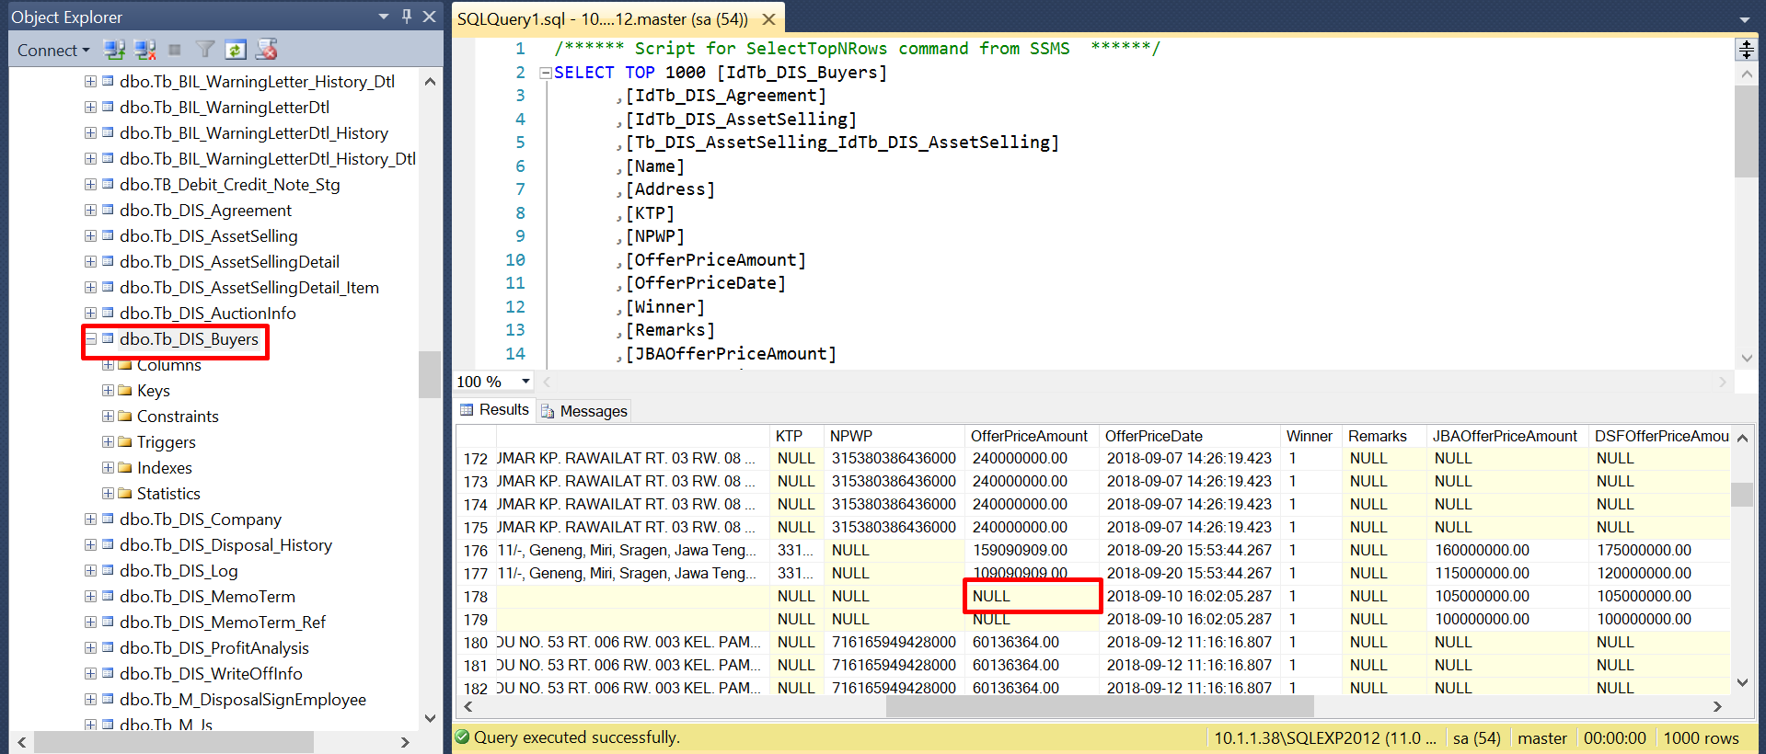Tb_DIS_Buyer (OfferPriceAmount is null)

Lesson Learn

1. If there's finding outside scope CR, make sure to check the risk first to prevent the error in the future.
2. If we agree to proceed the finding during UAT Phase, then always test full cycle since we have made new additional development.

**EVIDENCE**

UAT Evidence

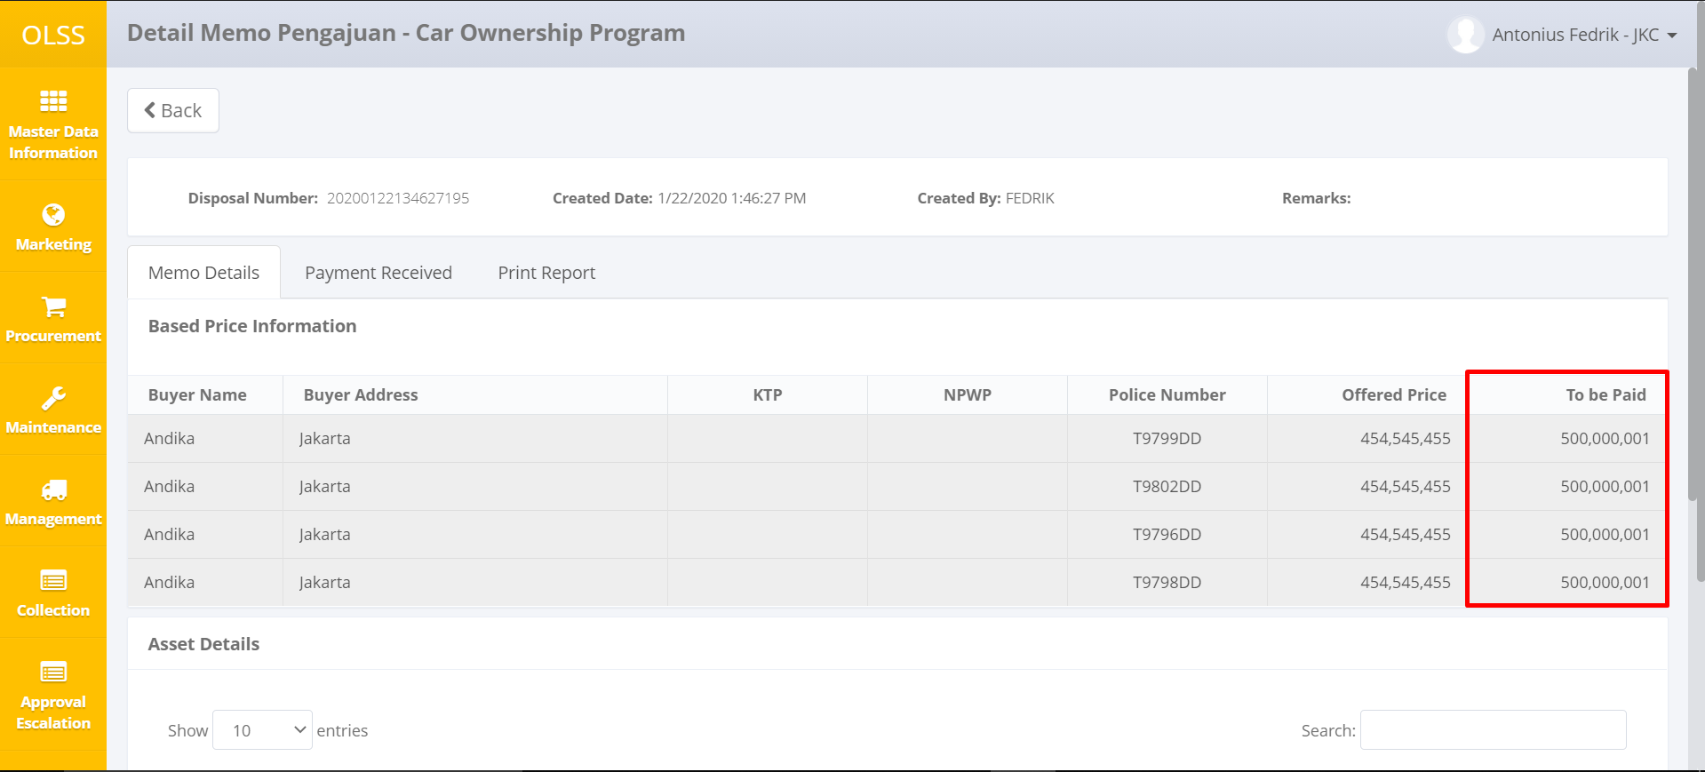

Before Change

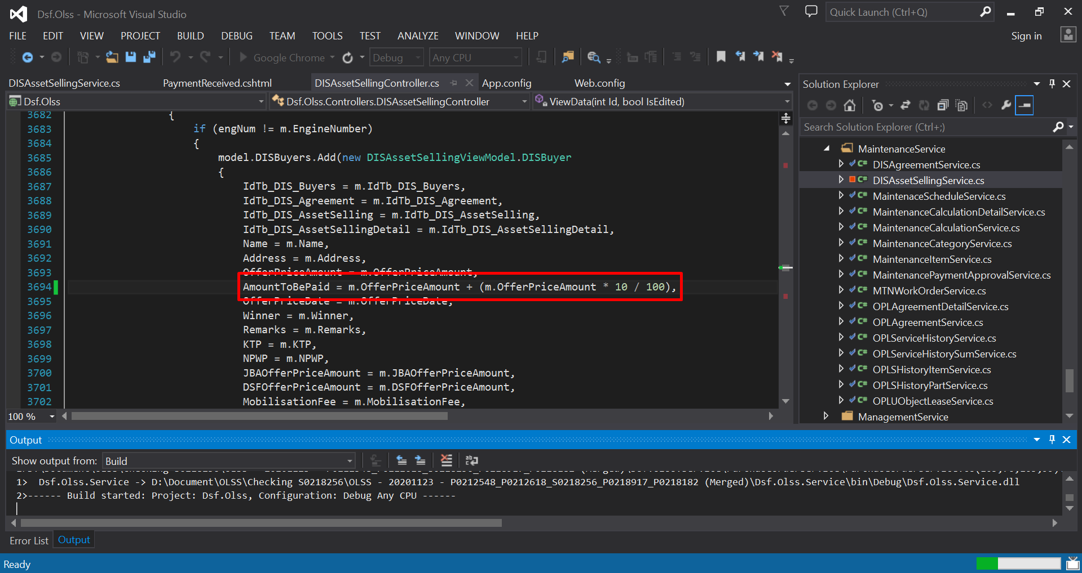

After Change

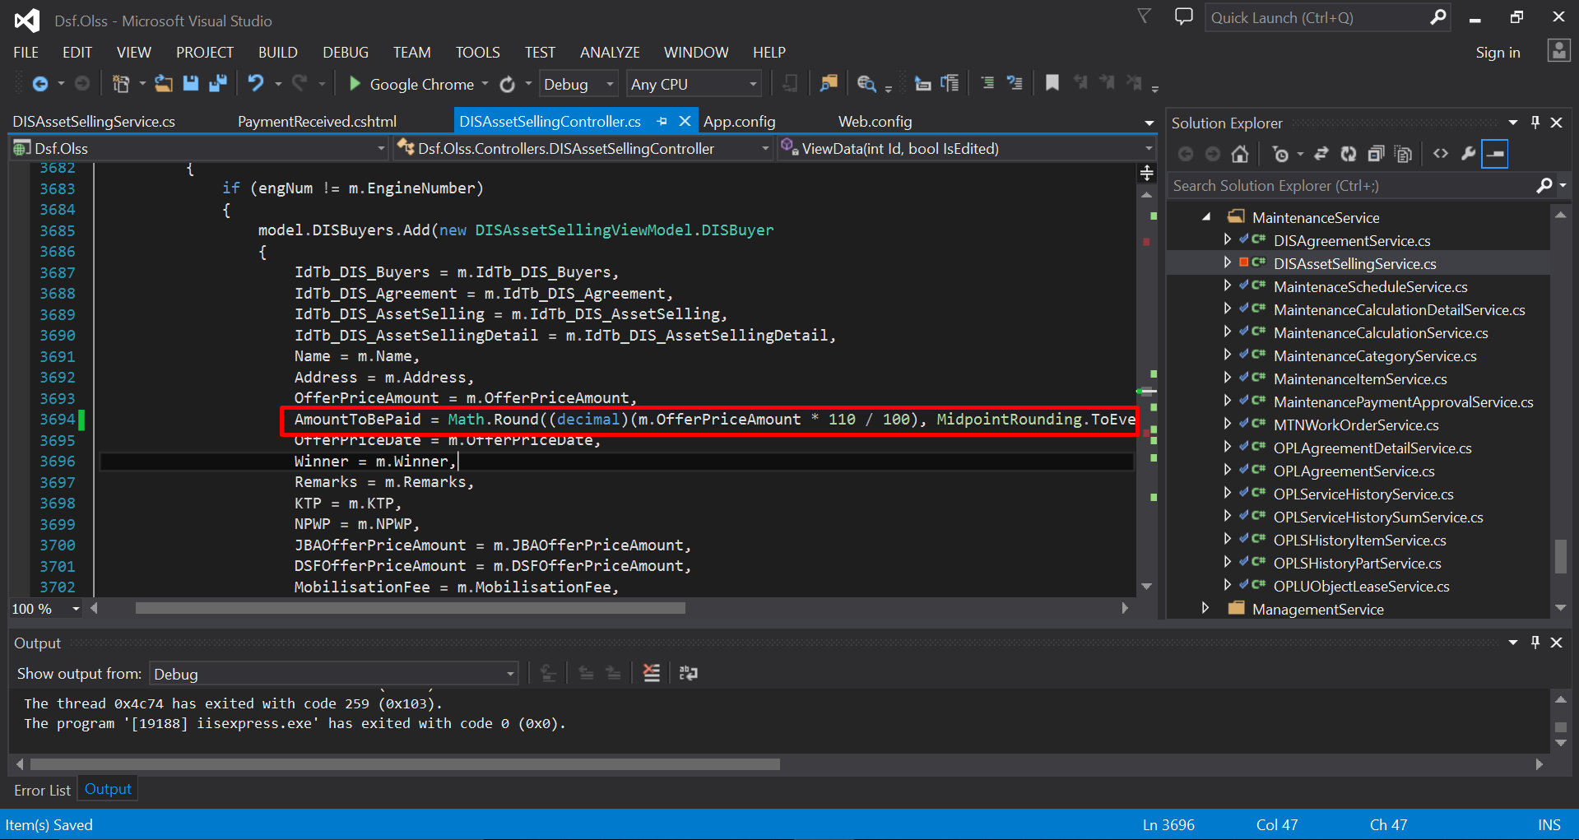

UAT Fixing

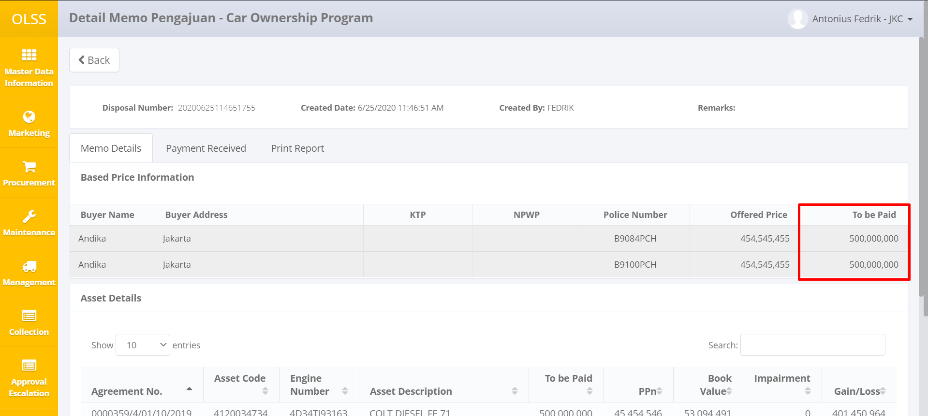

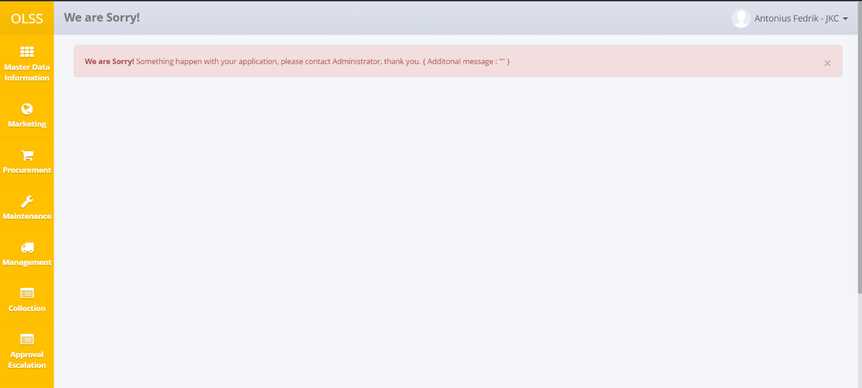Bug After Deployment